N-Queen Problem
Code Documentation
Backtracking Algorithm | Python | AI Lab

1. What is the N-Queen Problem?
The N-Queen Problem is a classic Artificial Intelligence puzzle. The goal is to place N chess queens on an N x N chessboard so that no two queens attack each other.

A queen can attack in 3 ways:

- Same Row — two queens in the same row will attack each other
- Same Column — two queens in the same column will attack each other
- Same Diagonal — two queens on the same diagonal will attack each other

For example, with N = 4, we need to place 4 queens on a 4x4 board so none of them can attack any other. This program finds ALL valid arrangements and prints them.

N (Board Size) | Total Valid Solutions
1 | 1
2 | 0 (no solution possible)
3 | 0 (no solution possible)
4 | 2
5 | 10
8 | 92

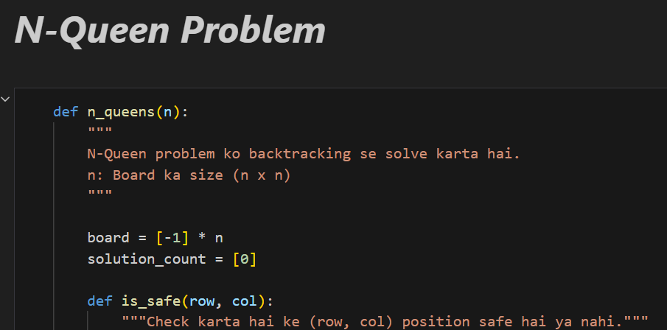

2. Complete Code
def n_queens(n):
board = [-1] * n
solution_count = [0]

def is_safe(row, col):
for prev_row in range(row):
same_col = (board[prev_row] == col)
same_diagonal = (abs(board[prev_row] - col) == abs(prev_row - row))
if same_col or same_diagonal:
return False
return True

def print_board():
print(f"\nSolution {solution_count[0]}:")
for i in range(n):
row_str = " ".join("Q" if board[i] == j else "." for j in range(n))
print(row_str)

def backtrack(row):
if row == n:
solution_count[0] += 1
print_board()
return

for col in range(n):
if is_safe(row, col):
board[row] = col
backtrack(row + 1)
board[row] = -1

backtrack(0)
print(f"\nTotal solutions for {n}-Queens: {solution_count[0]}")

n = int(input("Enter value of N: "))
n_queens(n)

3. Line-by-Line Explanation

Part 1 — Setting Up the Board
def n_queens(n):
board = [-1] * n
solution_count = [0]

- def n_queens(n) — defines the main function — n is the board size entered by the user
- board = [-1] * n — creates a list of n items, all set to -1. Each index represents a ROW. The value at each index represents which COLUMN the queen is placed in. -1 means no queen placed yet
- solution_count = [0] — a list with one value (0) to count how many valid solutions are found. We use a list instead of a plain variable because inner functions can modify list contents

Example: if n = 4, board starts as [-1, -1, -1, -1]. After placing queens it might look like [1, 3, 0, 2] meaning row 0 has queen at column 1, row 1 at column 3, and so on.

Part 2 — is_safe() Function
def is_safe(row, col):
for prev_row in range(row):
same_col = (board[prev_row] == col)
same_diagonal = (abs(board[prev_row] - col) == abs(prev_row - row))
if same_col or same_diagonal:
return False
return True

- is_safe(row, col) — checks whether it is safe to place a queen at the given row and column
- for prev_row in range(row) — loops through all rows above the current row where queens are already placed
- same_col = (board[prev_row] == col) — checks if a previous queen is in the same column — if yes, they would attack each other
- abs(board[prev_row] - col) == abs(prev_row - row) — checks if a previous queen is on the same diagonal. If the difference in columns equals the difference in rows, they are on the same diagonal
- return False — if same column OR same diagonal, this position is NOT safe
- return True — if no conflict found with any previous queen, the position is safe

Why we do NOT check same row: we only place one queen per row, so two queens can never be in the same row by design.

Part 3 — print_board() Function
def print_board():
print(f"\nSolution {solution_count[0]}:")
for i in range(n):
row_str = " ".join("Q" if board[i] == j else "." for j in range(n))
print(row_str)

- print_board() — prints the current board as a visual grid whenever a valid solution is found
- solution_count[0] — prints the solution number (Solution 1, Solution 2, etc.)
- for i in range(n) — loops through each row of the board
- "Q" if board[i] == j else "." — for each column j in the row — if the queen is at that column print Q, otherwise print a dot
- " ".join(...) — joins all the Q and . characters with a space between them to make a readable row

Example output for N=4, Solution 1:

. Q . .
. . . Q
Q . . .
. . Q .

Part 4 — backtrack() Function (The Core Logic)
def backtrack(row):
if row == n:
solution_count[0] += 1
print_board()
return

for col in range(n):
if is_safe(row, col):
board[row] = col
backtrack(row + 1)
board[row] = -1

- backtrack(row) — recursive function that tries to place a queen in each row one at a time
- if row == n — base case — if we have successfully placed queens in ALL n rows, we found a complete solution
- solution_count[0] += 1 — increase the solution counter by 1
- print_board() — print this valid solution on screen
- return — go back and look for more solutions

- for col in range(n) — try placing the queen in every column of the current row (0 to n-1)
- if is_safe(row, col) — only proceed if this position does not conflict with any previous queen
- board[row] = col — PLACE the queen — record that row's queen is at this column
- backtrack(row + 1) — move to the NEXT row and try to place the next queen (recursive call)
- board[row] = -1 — REMOVE the queen (backtrack) — undo the placement and try the next column

Part 5 — Starting the Search & User Input
backtrack(0)
print(f"\nTotal solutions for {n}-Queens: {solution_count[0]}")

n = int(input("Enter value of N: "))
n_queens(n)

- backtrack(0) — starts the backtracking from row 0 — the very first row of the board
- print Total solutions — after all solutions are found, prints how many valid arrangements exist
- int(input(...)) — asks the user to type a number N and converts the input text to an integer
- n_queens(n) — calls the main function with the number entered by the user — this starts everything
output screenshot:
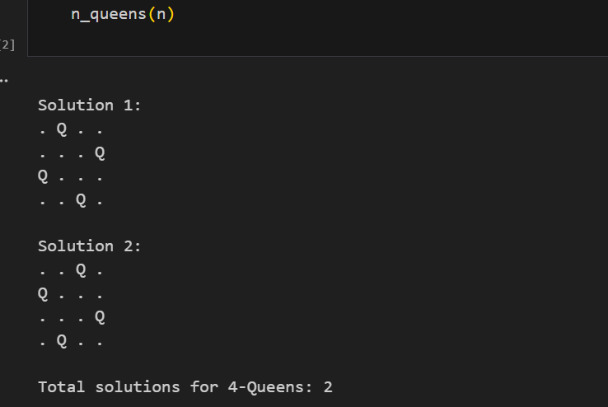

4. How Backtracking Works
Backtracking is like solving a maze by trial and error:

- Step 1 — start at row 0, try placing a queen in column 0
- Step 2 — if safe, move to row 1 and try each column there
- Step 3 — keep going row by row, placing queens where safe
- Step 4 — if you reach row n, all queens placed successfully — record the solution
- Step 5 — go back (backtrack) and try the next column in the previous row
- Step 6 — if no column works in a row, go back one more row — keep backtracking
- Step 7 — repeat until all possibilities are explored

The key idea: place a queen, go deeper, if it fails remove the queen and try somewhere else. This guarantees ALL solutions are found.

5. Example: N = 4
The program finds 2 valid solutions for a 4x4 board:

Solution 1 | Solution 2
. Q . . | . . Q .
. . . Q | Q . . .
Q . . . | . . . Q
. . Q . | . Q . .

In Solution 1 the queens are placed at columns: row 0 → col 1, row 1 → col 3, row 2 → col 0, row 3 → col 2. No two queens share a row, column, or diagonal.

6. Function Summary
Function / Variable | Purpose
n_queens(n) | Main function — sets up the board and starts the search
board = [-1] * n | Stores which column each row's queen is placed in
solution_count = [0] | Counts how many valid solutions have been found
is_safe(row, col) | Returns True if placing a queen at (row, col) is safe
same_col check | Ensures no two queens share the same column
same_diagonal check | Ensures no two queens share the same diagonal
print_board() | Prints the board as a Q/dot grid for each solution
backtrack(row) | Recursively places queens row by row using backtracking
board[row] = col | Places a queen (records the column)
board[row] = -1 | Removes a queen (undoes the placement — backtrack step)
backtrack(0) | Starts the entire search from row 0
int(input(...)) | Gets the board size N from the user

N-Queen Problem | Backtracking | AI Lab Documentation

